**Understanding the Basic Game**

**Engine, Server, Network Protocol and**

**beyond**

**1st Project  Part 2**

**by**

**George Jone**

Server (& Client) Development (5 Points)  Requirements: Basic Client and Server Code

Server Login Verification (2.5 Points)

The hardcoded data is in a class called VerifiedUsers. If the user does not have the correct username and password pair, then they will be prompted that they failed to log in. If they have the correct credentials, then they can continue with the login process.

I successfully modified the existing login protocol to verify a user. The verification functionality is mostly working. There is a bit of strange behavior when multiple users attempt to log on though.

I mostly had trouble figuring out what client.getPlayer().getID() is supposed to be grabbing. I had to modify that value so the code would stop crashing.

The extension of the ResponseLogin was not a problem to implement.

User ID is set to the value of username and is sent back to the client. Player level and Money are set to 0 in the class PlayerData andis sent to the client.

All pertinent data is output in the Unity console.

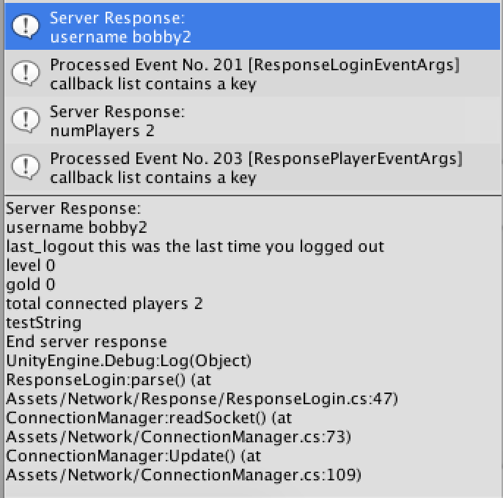

Retrieve Number of Connected Players (2.5 Points)

I made the new protocol, and there is communication between the client and the server. After a user has been verified, the client makes the request and the server responds with the number of connected players (shown in above image).

Server Team Assignment

Made the new protocol but did not do the tests.

Client Team Assignment

I ported the code to android and it is mostly working.

